Museum of Science and Discovery Quick Reference

Loc D. Tran

Florida Atlantic University

Abstract

In this era where technologies unify people abroad, the pocket is a place where many decisions and discoveries are made. Therefore, the creation of a mobile application for the Museum of Discovery and Science will bring forth the best of the museum and allow users to enjoy the rich experience of the museum at the comfort of their own time and space. Recent studies suggest that people tend to rely on mobile devices and applications for socialization and education. Digitizing the Museum of Discovery and Science allows for more potential visitors for the museum, considering an android mobile application is versatile and available to all who possess an android device. To build an application for the Museum of Discovery and Science, a team of three specialized novices were assembled to perform three different, essential jobs that would be combined to form a fruitful product. By incorporating Eclipse, Processing, and Adobe Photoshop, an application was created to inform users about the Museum of Discovery and Science.

Museum of Discovery and Science Quick Reference

Throughout a 24 hour period, people frequently check their mobile devices for incoming texts, messages, and news reports through mobile applications. Therefore, it is crucial to understand that one prominent way to inform people across the world about certain issues is to introduce those issues to them via mobile applications. Less and less people are informed about the events, technologies, and environments around them due to the lack of mobile applications for such purposes. Museums, such as the Museum of Discovery and Science, is a gateway for people to be informed about various topics. If a mobile application is to be tailored specifically for the Museum of Discovery and Science, more people would stop by and visit.

For instance, applications created for the British Museum and MoMa had received a high rating in the Android Play Store for helping people explore the museums in their pockets. The creation of an application for the Museum of Discovery and Science will bestow fortunes on both the creators and the museum itself.

**Method**

**Dividing Responsibilities**

The development of our application for the Museum of Discovery and Science, MODSQuickRef, consisted of our team dividing the responsibilities into three individuals. Each person in our group of three was in charge of the three varying roles: Manager, java programmer, artist. By dividing up the responsibilities, no individual was forced to carry the burden of his or her entire team. The manager was responsible for being the primary authors of the many papers required for the completion of MODSQuickRef. The java programmer was responsible for portraying the ideas of the manager and the artist into the application. Finally, the artist was in charge of designing and creating assets for the application.

**Materials and Procedure**

Before the actual application was developed, the artist had to use Balsamiq software to create a mockup of MODSQuickRef, which included all of its screens and buttons. Without the mockups, there would have been no foundation for the Java programmer to follow. With the mockups completed, the manager had to work with the artist on Adobe Photoshop to create a storyline on how the users will use MODSQuickRef. As many as possible combinations of situations were named by the artist and the manager in order for the Java programmer to know what to prioritize in the development of MODSQuickRef.

With all the preliminaries completed, the Java programmer had a firm idea of his or her responsibility. In our group, the Java programmer used Eclipse to code the foundation for our app. The artist used Adobe Photoshop to filter images found on various websites in order to generate an aesthetic experience in our app. In the end, with the app completed, the manager is the author of the final report and the organizer of the entire group’s wiki page on Confluence.

**Results**

When we combined our materials into one, the result was MODSQuickRef. Our functional application is capable of showing the users the current opening and closing hours of the Museum of Discovery and Science, a calendar showing special events, and a direct link to Google Maps with the address pre-installed, as well as information about the museum’s turtle exhibits.

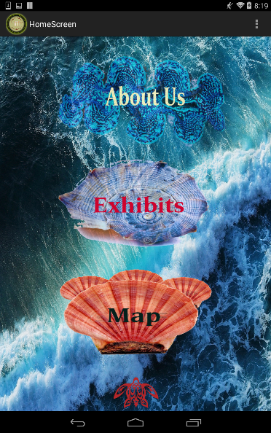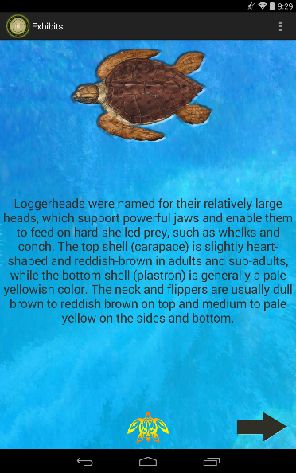This is our HOME screen. The MODS logo takes the user to a preset Google Map page. "Today's Hour" and "Special Event" takes the to the MODS website.


Figure 3 shows our “Exhibits” section with short and terse information.

Figure 2 shows our MENU drawer with buttons filled with images referencing to the environment in which sea turtle thrives in

Figure 1 shows our MODSQuickRef application HOME screen with four buttons.

To adhere to our turtle theme, we have filtered and edited images that has some association with turtles, such as a turtle home button and nature related backgrounds. The information that we put in our “Exhibits” section is short, terse, and straight to the point. We tried to make it so that readers of all ages can understand more about the exhibit at hand.

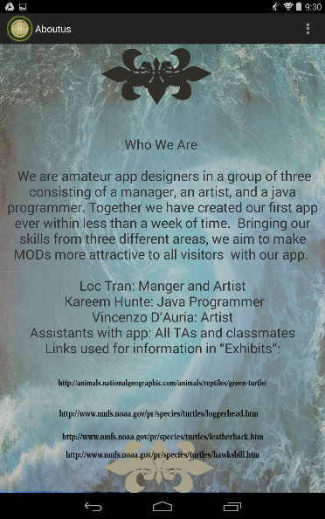

Figure 4 shows our “About Us” page where we acknowledge the help we have received along the way.

We did not want to commit the act of plagiarism in any way. Therefore, we even dedicated a screen to give credit to the people who had helped us and the resources that we used to achieve our final product.

**Discussions**

Using various methods and codes in Eclipse, such as image buttons, regular buttons, and text views, we were able to generate a simple UI that is colorful for users. We aimed for our UI to be so simple that even the youngest and oldest of all users can easily navigate through our application to learn more about the Museum of Discovery and Science and its exhibits. By incorporating image buttons, we feel it is easier for users to connect with the exhibit we displayed: the turtle exhibit. Using just a regular button is too plain and looks unnatural considering it would have been on top of a background displaying nature.

Even though we tried to make MODSQuickRef’s UI clean and simple, we feel that a tutorial screen is still needed in order to show the users the full extent of our application. For example, it might be hard for a user to figure out that the turtle at the bottom of every screen is the HOME button.

**Conclusion**

In the end, we have accomplished our initial goal to make a mobile application for the Museum of Discovery and Science that is as user friendly as possible. Along our journey, we have encountered numerous obstacles with coding and creating aesthetic assets for our application. However, with the help of Dr. Shankar’s teaching assistants and wonderful classmates, we were able to overcome our difficulties, unite, and finalize the application of our dream.

**References**

"The Atlantic Green Sea Turtle | Publish with Glogster!" *Glogster*. Web. 01 July 2014.

"Fort Lauderdale Museum of Discovery and Science - Florida, USA. Ft Lauderdale, FL." *Fort Lauderdale Museum of Discovery and Science - Florida, USA. Ft Lauderdale, FL.* Web. 01 July 2014.

"Green Turtles, Green Turtle Pictures, Green Turtle Facts - National Geographic." *National Geographic*. Web. 01 July 2014.

"Hawksbill Turtle (Eretmochelys Imbricata)." *:: NOAA Fisheries*. Web. 01 July 2014.

"Leatherback Turtle (Dermochelys Coriacea)." *:: NOAA Fisheries*. Web. 01 July 2014.

"Loggerhead Turtle (Caretta Caretta)." *:: NOAA Fisheries*. Web. 01 July 2014.

"Museum of Discovery and Science Announces Grand Opening of New EcoDiscovery Center on Friday, November 11, 2011." *Miles Austin Forman*. Web. 01 July 2014.

"Sea Shell Isolated on White Background." *123RF Stock Photos*. Web. 01 July 2014.

"Sea Turtles." *Pinterest*. Web. 01 July 2014.

**Appendices**

**Appendix A –** Assets

**Appendix B** - Codes